Lord may these words from my mouth and this meditation of our hearts be pleasing in your sight. Amen
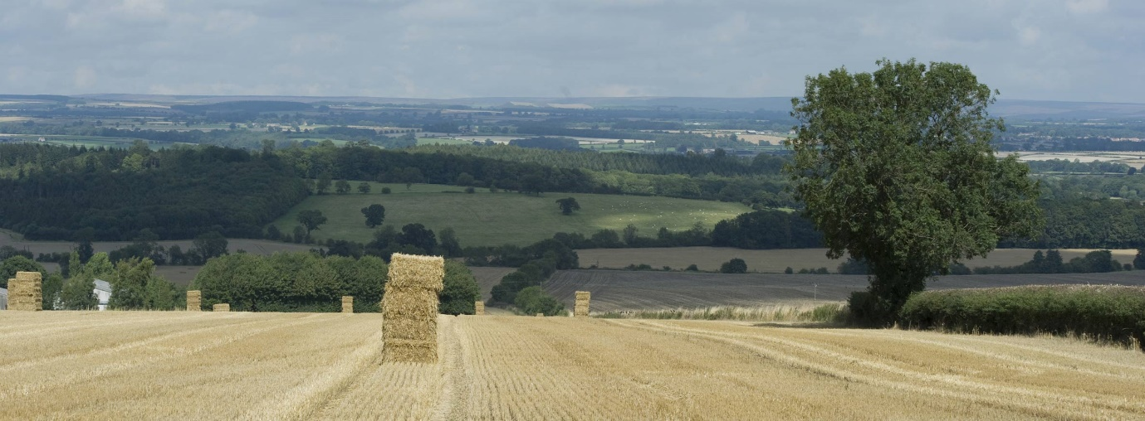
Take a look around you…..we live in a beautiful place…..they don’t call it God’s own County for nothing….and isn’t it amazing that even Jesus knew the importance of our farming community….even he knew that the work of a farmer was back breaking….and the farmer would never have enough people to do all the work needed….The Jesus of our gospel reading today clearly focused on the future….and the future depends on a good harvest and enough people to help.

I won’t profess to be knowledgeable in farming terms and processes, but I think I can say with some confidence that there is a rhythm of life that the farmer will grow to appreciate more than most. There will be time to prepare the ground…then to sow the seed….to bring in the crop….and then a whole new journey starts when the crop has been harvested…..some make flour for bread…..some for cakes…..potatoes are harvested for crisps…..chips…..or gin.

Love is at the heart of what our farmers do….it must be, because the hardship and constant toil to bring in a successful harvest would leave most of us looking for a way out…..The harvest in plentiful, but the labourers are few…

I’m going to ask you all now to do something which would normally be frowned upon in church….and all you watching at home can join us too…..I would like you to take out your mobile phone if you have one….and….obviously as you are all good churchgoers, you will have turned it off…..so please turn it on.
I would like you to think of someone who you haven’t spoken to for a while….just the first person that comes to mind…..and I would like you to send them a text message…..just say….I am in Church and you came to mind. I am praying for you…..don’t over think it or offer any more explanation….
I’ll give you a moment to do that…
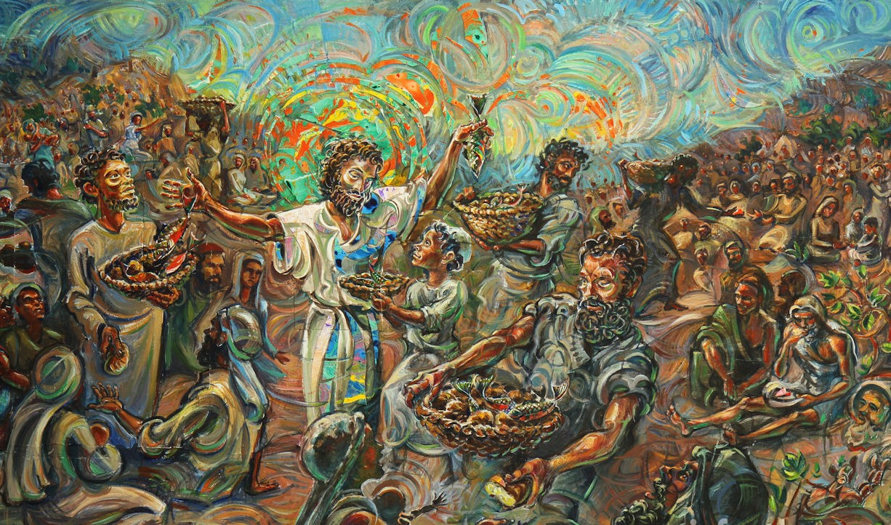
This picture depicts the feeding of the 5000…..We too often in today’s society see those who are hungry….we have our own food bank in Richmond who are inundated with calls for help…..a church just down the road is asking for donations coats as there are children and adults without a suitable coat for the coming winter….
More than ever we have seen people in need…..not just on the news or in third world countries….and thank god….more than ever we have seen our communities come together to help each other when people are struggling….The harvest festival services have seen the food bank overflowing with support….yet it always needs more……donations of coats and jackets are coming in thick and fast….but they go out of the door just as fast…..
This is a picture of our harvest….ok it’s actually a picture of the tour de Yorkshire coming through Richmond….but these people are the community in which we live…..in which we love…..and in which we worship and minister….you and I are called out like lambs into the midst of wolves…..but with a coat of armour which is the holy spirit……Don’t be afraid to speak of your faith….even a seed scattered on the cobbles of Richmond market place can find root…..Our harvest is a harvest which will see our labouring on the word…..and the actions of the lord…..we need to be seen as a church and a community who embrace the harvest and reap the rewards by a growth in faith…and in number…..a growth that surpasses all understanding…
The harvest is plentiful, but the labourers are few…..who alone is going to bring in the harvest….who can go out there and spread the good news about the harvest on their own…..who as an individual is going to defend those in need….me? because I wear a funny shirt and a fancy frock…….nope……well what if I were to wear a different cape ..
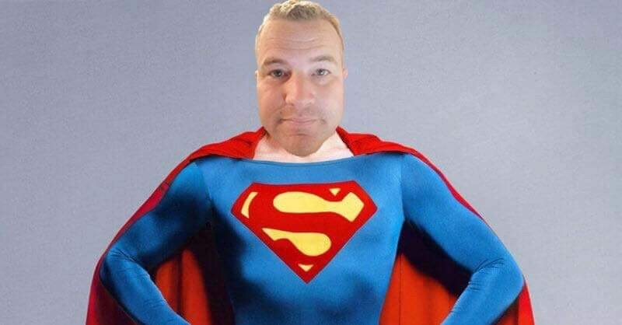
…..maybe one like this???? SUPERMAN…obviously if I were superman I would be clean shaven!!!
One person….even a Super Curate….cannot do this alone…..yes the harvest is plentiful and we have a community eager to know of the love that is found in Jesus’ crucifixion and resurrection…..join me….super cape or no super cape……let our rule of life be one that’s sees our passion and energy used to encourage….to pray…..to share our stories and to share our good fortune with those who are struggling…..I am not asking for thousands of pounds….although that would be great….I am asking for you to consider what you can do……that may be a gift of your time….it may be a bag of pasta or some tins…..it may be a coat which you never wear being passed to a young mum who can’t make ends meet……it may be increasing your giving to church, so that we can do more….it may even be as simple as sending a text….making a phone call….or knocking on the door of someone you haven’t seen in a while and just letting them know that you are praying for them…
After the service I would be really interested to hear the reactions and the replies that you have had from your text messages. Pastoral Care is the word we use in the church for making sure those around us are ok…..it comes from a place of love….In the coming weeks we as a church community need to come together to ensure we are all offered pastoral care…..watch this space for how we intend to do this better…..and please understand that care and love are offered freely by those who offer it with joy in their hearts.
You don’t need to be superman to make a difference…..
be that labourer who….with others….really makes a difference……but also don’t be afraid to say…I need prayer….I need help….we are a community brought together through faith and love….peace be with you and your house, today and always.

Amen

